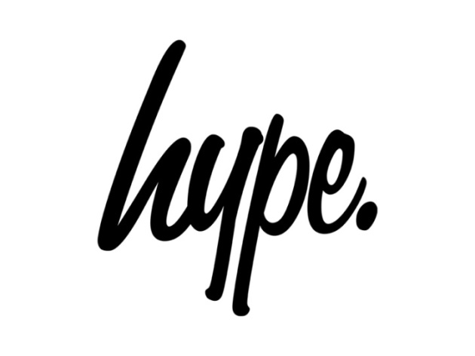

**Returns information**

All returned items must be unworn, complete with all original tags, in original condition and returned within 28 days of receipt of your order.

We reserve the right to refuse a return if it fails to meet the above terms. These terms do not apply to faulty items.

We recommend using a tracked service, so that we can track the parcel if it goes astray whilst in transit.

We do not exchange products, unless they are faulty or incorrect.

A refund will be debited back to the payment method used for the order.

Please allow up to 3 days from receipt for your return to be processed.

Please contact our customer service team at orders@justhype.co.uk with any queries.

Please return this form, along with the unwanted item/s to:

Returns Department

Just Hype

Unit 13 Chartwell Drive,

Wigston,

Leicestershire

England

LE18 2FN

The refund policy does not affect your statutory rights.

Returns Form

|  |  |  |
| --- | --- | --- |
|  |  |  |

**Order Number Customer Name Order Date**

1. Doesn’t fit properly
2. Poor quality
3. Style does not suit
4. Arrived too late
5. Not as expected
6. Unwanted gift
7. Faulty item

Quantity Product Name Size Reason Code

|  |  |  |  |
| --- | --- | --- | --- |
|  |  |  |  |
|  |  |  |  |
|  |  |  |  |
|  |  |  |  |
|  |  |  |  |
|  |  |  |  |

Reason for return

**Please fill in the following fields if an item is faulty:**

|  |
| --- |
|  |

Product Name Description of fault Refund Exchange for replacement product

**Reason for return**

1. Doesn’t fit properly

2. Poor quality

3. Style doesn’t suit

4. Arrived too late

5. Not as expected

6. Unwanted gift

|  |  |
| --- | --- |
|  |  |

Product Ordered Product Received

**Please fill in the following fields if an incorrect item was received:**