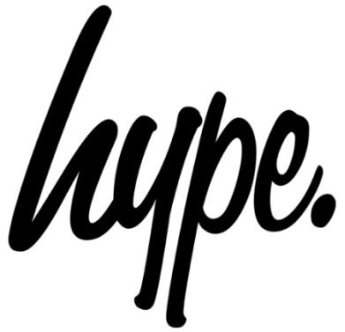
Returns information
All returned items must be unworn, complete with all original tags, in original condition and returned within 28 days of receipt of your order.

We reserve the right to refuse a return if it fails to meet the above terms. These terms do not apply to faulty items.

We recommend using a tracked service, so that we can track the parcel if it goes astray whilst in transit.

We do not exchange products, unless they are faulty or incorrect.

A refund will be debited back to the payment method used for the order.

Please allow up to 3 days from receipt for your return to be processed.

Please contact our customer service team at orders@justhype.co.uk with any queries.

Please return this form, along with the unwanted item/s to:
Returns Department
Just Hype
Unit 13 Chartwell Drive,
Wigston,
Leicestershire
England
LE18 2FN

The refund policy does not affect your statutory rights.

Returns Form
Order Number Customer Name Order Date
- Doesn’t fit properly
- Poor quality
- Style does not suit
- Arrived too late
- Not as expected
- Unwanted gift
- Faulty item
Quantity Product Name Size Reason Code

Reason for return

Please fill in the following fields if an item is faulty:
Product Name Description of fault Refund Exchange for replacement product
Reason for return
1. Doesn’t fit properly
2. Poor quality
3. Style doesn’t suit
4. Arrived too late
5. Not as expected
6. Unwanted gift

Product Ordered Product Received
Please fill in the following fields if an incorrect item was received:

